STAFF UPDATE TEMPLATES

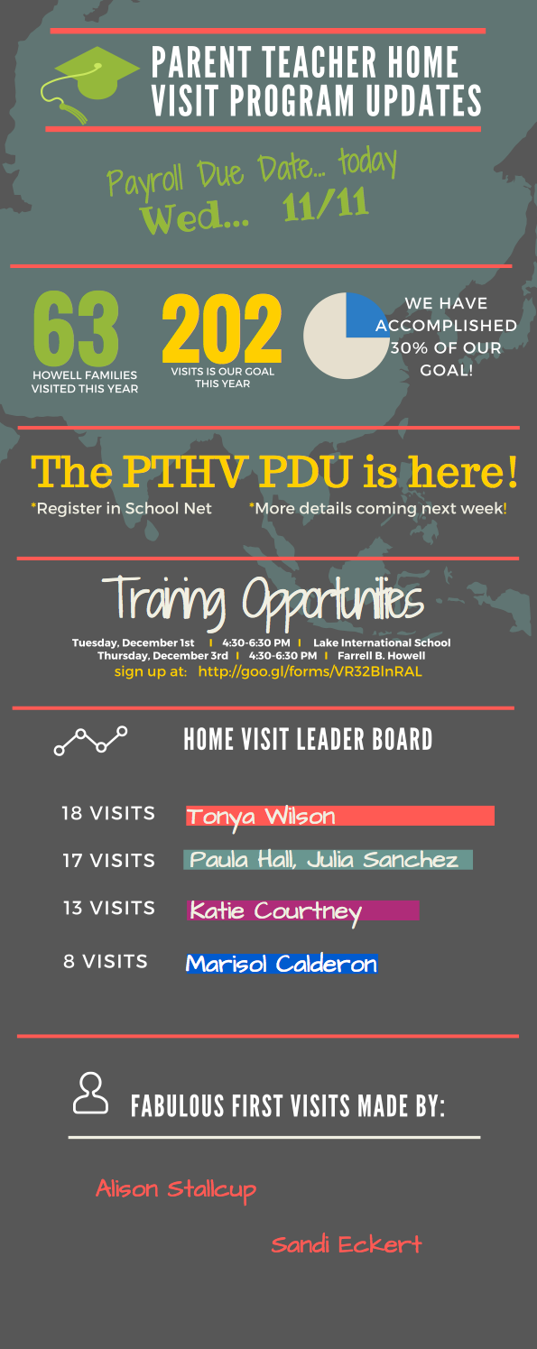
INFOGRAPHIC

This is a great tool designed by Bonnae Hammond, Site Coordinator at Farrell B Howell. Bonnae uses this to communicate updates and shout-out’s to her staff regarding PTHV participation. If you’d like to use the template she created, go to http://bit.ly/1PwMQpM or check out www.canva.com to create your own infographic

EMAIL NEWSLETTER

If you and your staff prefer to connect via standard email, check out this monthly newsletter created by Donna Laffitte and Eve Ulloa, Site Coordinator at Castro Elementary. Eve and Donna use this tool to celebrate staff as well as remind them about key deadlines and procedures for PTHV. Use this as a template and adapt for your own team.

Good Afternoon Everyone!
Congrats to _______, ________, _______ and _______ for completing home visits. We have a total of _____ visits! ______ and ______ have completed 12 and _______ and _______ completed 9. AWESOME!!!!!!!! I know that you all have shared your positive experiences with staff and have sparked others to schedule future visits. Developing strategies will be helpful in getting everyone involved. We have attached the students that were visited this month. We have also attached the October Payroll Coversheet for the upcoming payroll. I recommend you save to your desktop and enter the visits as you go, this will help in your organization and ensure that we have ALL the visits. Remember that when you are submitting your paperwork, you ONLY submit your paperwork, not your secondary support. All of the Math Fellows have received training and are ready to attend visits, so please reach out to them.
IMPORTANT - You must attend a Parent Teacher Home Visit training prior to attending any visits. We have posted information for upcoming trainings.

The NOVEMBER payroll will be due Thursday, November 12, 2015!!!!!!!!!!!!!!!!!!!!
Moving forward, however, all home visit documentation must be turned in by the 9th of the month in order to ensure payment for the current month. We will need to check your paper work and have you sign the payroll sheet. You can bring your payroll to Room ____ during your specials time prior to 2:30 p.m. If you have scheduled a visit on the 14th, inform parents of the payroll and date your paperwork for the following day.
-------------------------------------------------------------------------------------------------------
As we continue building the bridges with our families and community, we wanted to share some reminders as to the guidelines/parameters prior to getting started. There are a few changes, so please read over the parameters and let us know if you have questions or you need more clarification. All staff members attended a payroll collection meeting and received a notebook to use for the visits and data collection. If you do not have a notebook, please email _____. We want to get one to you!
Below you will find the parameters of the PARENT TEACHER HOME VISIT PROGRAM- please see Eve if you have questions.
CONDUCTING VISITS
1. All visits must be conducted with TWO staff.

ACCEPTABLE PARTNERS: TEACHERS AND TEACHERS | TEACHERS AND PARAPROFESSIONALS | TEACHERS AND SPECIALS

UNACCEPTABLE PARTNERS: SPECIALS AND PARAS | SPECIALS AND SPECIALS P

2. All visits must have a half sheet signed by the parent and both staff members . The documents are in Room 152 and/or see Ms. Ulloa.

3. All visits must be entered into Infinite Campus prior to turning them in to the Site Coordinator (Ms. Ulloa).

4. Staff will enter employee ID# and the School #-287 in IC. IC will not close out until this is done. The primary teacher will need to enter both their ID and their partner's ID.
5. All sheets must be turned in during the payroll month that the visit was conducted. You cannot hold on to the visits and turn them in when you wish—we have a prepopulated form in IC that we must complete; so please turn your paperwork in when requested!

6. Please hold on to all HOPES AND DREAMS sheets so that you can reference them at a future time (you DO NOT need to submit these to your Site Coordinator).

7. Beginning in December, home visit paperwork must be submitted to Eve by the 10th of each month. If it isn’t turned in on time, you will not receive compensation until the following month.

8. When submitting, complete the graphic organizer that will be used as your cover sheet (I will send this document in an email).

9. At the end of each payroll month, the PTHV office will compare home visit payroll sheets to the home visits logged into IC, if they do not match, the PTHV office will return the payroll sheet to the Principal and Site Coordinator until the IC visits match the payroll home visit sheet, for that month.

10. Visits should not occur at school functions, or on school property.

11. Paraprofessionals that work 35 hours per week can only complete 5 visits per week.

12. If any items are not adhered to, payment will not be forwarded for the teacher or staff person (as per the district communication).

13. Hopes & Dreams field allows only 75 characters (spaces, commas, periods are included) and you can submit in Spanish.

15. ****PLEASE CHECK YOUR SPELLING, PLEASE RECORD ONLY A HOPE & DREAM IN THIS FIELD- THIS IS VERY IMPORTANT AS IT WILL BE DISPLAYED IN THE OPENING WINDOW OF THE PORTALS FOR PARENTS TO SEE****

Thank you all for your dedication to building relationships with our families and to the Parent Teacher Home Visit Program! If you have any questions or concerns, please feel free to contact us.

Thanks…Eve and Donna

