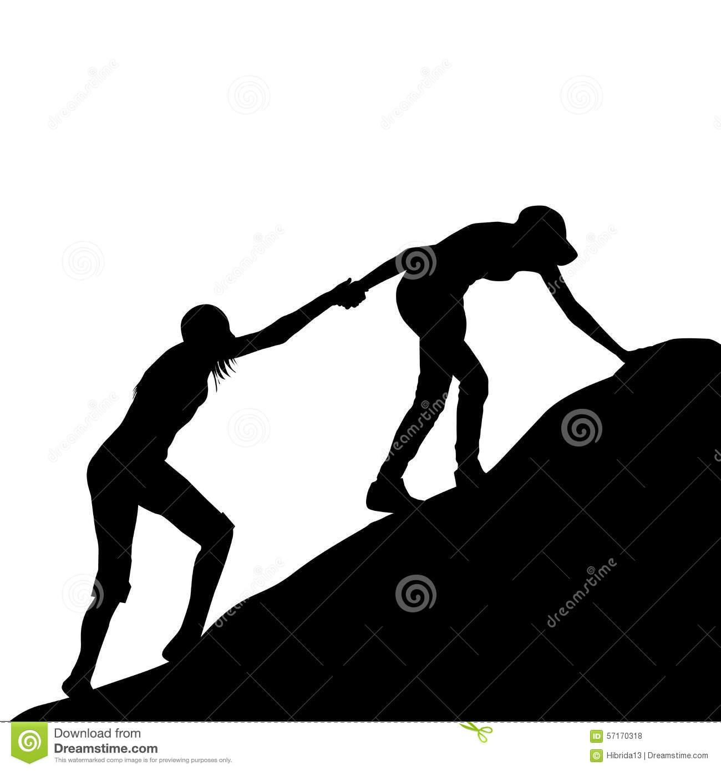 Creating a Family School Partner SMART Goal- Elementary

1.Here is what I want my child to achieve (Big Goal):
ex. (3rd grade) My student will be on grade level in reading.

2. Here is my SPECIFIC goal:
ex. (3rd grade) My student will be able to describe the characters in a story and explain how their actions contribute to the sequence of events.

⏭ S
3. Here is my main MEASURE for this achievement (what I will see, hear, feel when we have accomplished the goal from #1)
ex. I will see my third grader is able to write about characters in detail and explain how their actions contribute to the plot. I will hear her make connections between the characters and the events in the story.

⏭ M
4. Now, put those two together:
Ex. (Who) My child (What) will be able to describe the characters and explain how their actions connect to the plot (When) by May (How) through us reading together each night at home and asking questions about the characters.

Who (your child): __________________________________________________________
What (the main goal):______________________________________________________
________________________________________________________________________
By When: _______________________________________________________________
How (from the Family School Partner Strategies sheet!):
1.______________________________________________________________________
2.______________________________________________________________________
3. ______________________________________________________________________
5. To finish, go through the rest of the SMART goal checklist:
- Is your goal ATTAINABLE? ⏭ A
- Is it RELEVANT to the Big Goal? ⏭ R
- Is it TIMED? ⏭ T

Congratulations! You have created a SMART goal!

SMART Goal Action Plan

Strategy 1
What (Strategy) | Who is responsible? | Where will it happen? | When will it happen? | Why is this important?

Strategy 2
What (Strategy) | Who is responsible? | Where will it happen? | When will it happen? | Why is this important?

Strategy 3
What (Strategy) | Who is responsible? | Where will it happen? | When will it happen? | Why is this important?

