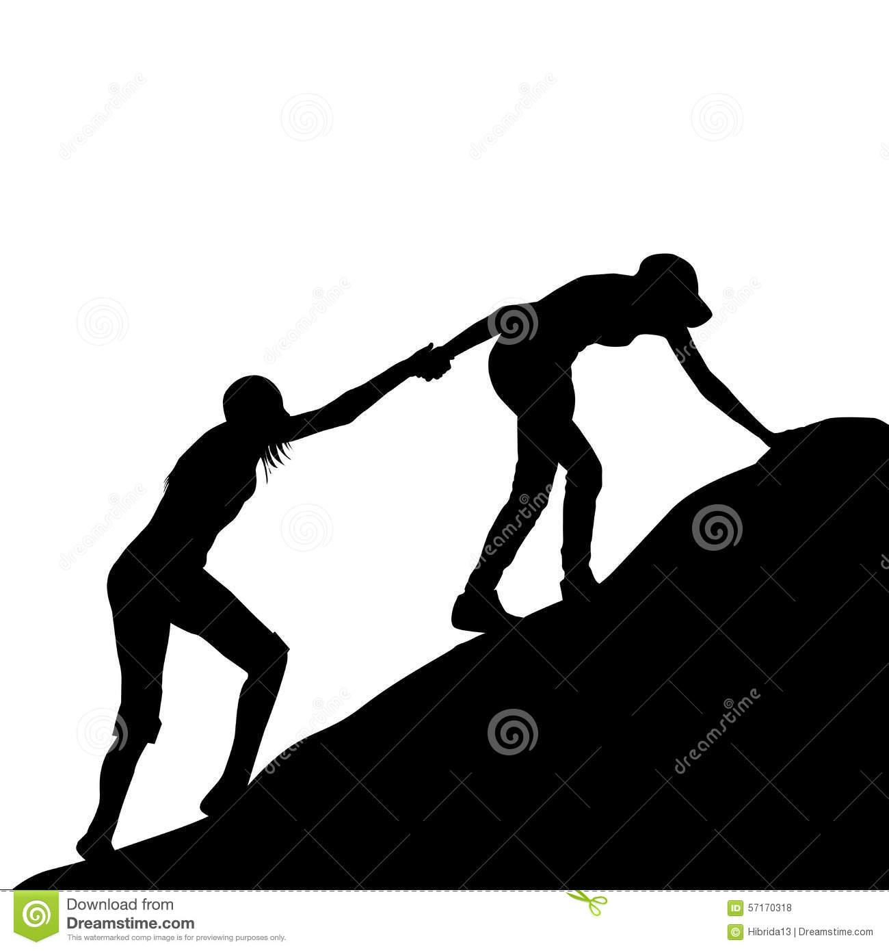 Creating a Family School Partner SMART Goal- High School

1.Here is what I want my child to achieve (Big Goal):
ex. (9th grade) My student will be on grade level in reading.

2. Here is my SPECIFIC goal:
ex. (9th grade) My student will be able to analyze how complex characters develop over the course of a text.

⏭ S
3. Here is my main MEASURE for this achievement (what I will see, hear, feel when we have accomplished the goal from #1)
ex. I will see my ninth grader is able to describe characters’ development in writing. I will hear her explain how the characters have developed throughout the text.

⏭ M
4. Now, put those two together:
Ex. (Who) My child (What) will be able to explain how complex characters develop over the course of a text (When) by May (How) through us talking about texts she has read and answering questions about the characters.

Who (your child): ____________________________________________________________
What (the specific goal):_______________________________________________________
___________________________________________________________________________
By When: __________________________________________________________________
How (from the Family School Partner Strategies sheet!):
1._________________________________________________________________________
2._________________________________________________________________________
3. _________________________________________________________________________
5. To finish, go through the rest of the SMART goal checklist:
- Is your goal ATTAINABLE? ⏭ A
- Is it RELEVANT to the Big Goal? ⏭ R
- Is it TIMED? ⏭ T

Congratulations! You have created a SMART goal!

SMART Goal Action Plan

Strategy 1
What (Strategy) | Who is responsible? | Where will it happen? | When will it happen? | Why is this important?

Strategy 2
What (Strategy) | Who is responsible? | Where will it happen? | When will it happen? | Why is this important?

Strategy 3
What (Strategy) | Who is responsible? | Where will it happen? | When will it happen? | Why is this important?

